|  |
| --- |
|  |
| Hardware Manual for Thumper |
| Assembly Guide - Version 1.1 |
|  |
| **Wangyi Zhu** |
| **2014/5/21** |

Table of Content

**Instruction2**

**Installation3**

**Appendix11**

1. **Introduction:**

This manual is a guide to help user to assemble the thumper robot. Users can purchase all parts online on their website. Links are provided in a table in appendix.

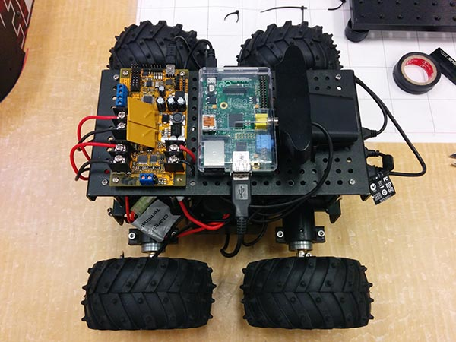 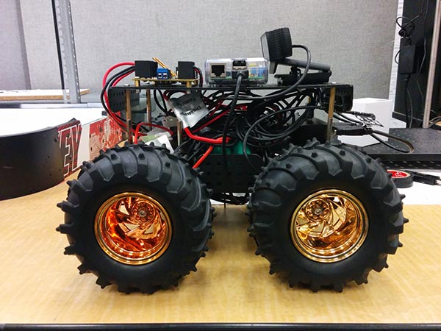

Fig1. Top view of thumper Fig2. Side view of thumper

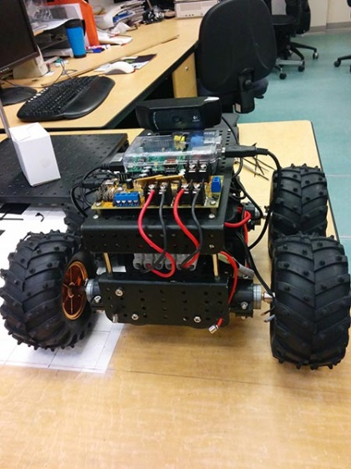 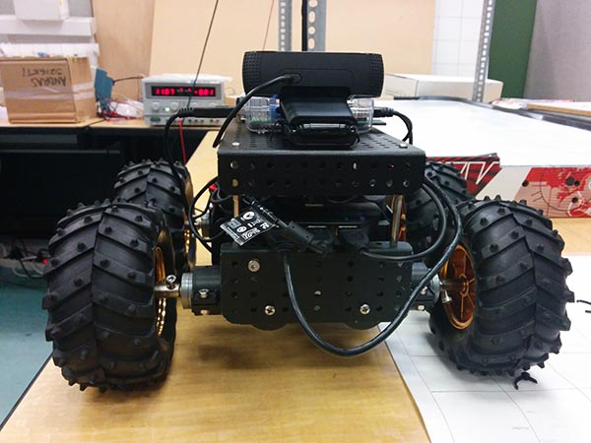

Fig3. Front view of thumper Fig4. Back view of thumper

1. **Installation:**

Step1:

You should have the wild thumper 4WD build complete. This is the base of the robot. It shows as figure 5.

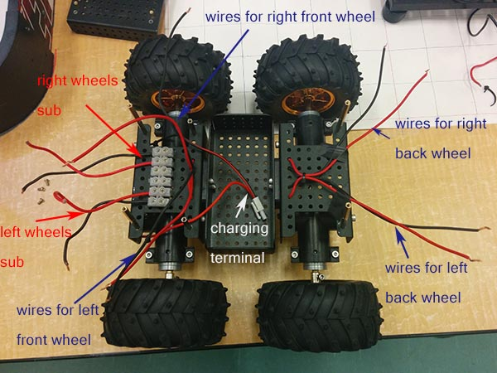

Fig 5. wires for thumper robot

Step 2:

Grouping the wires for left/right wheels and then link them to left/right wheel bus through connection docks.

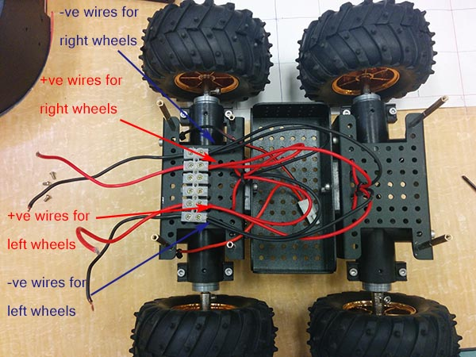

Fig 6. Wire connection for left/right wheels

Group up the positive and negative wires for left/right wheels and put into connection dock. Use screwdriver to stable the wire groups.

Step 3:

Place the usb hub at the front of the frame.

In fig 7 it shows the usb hub.

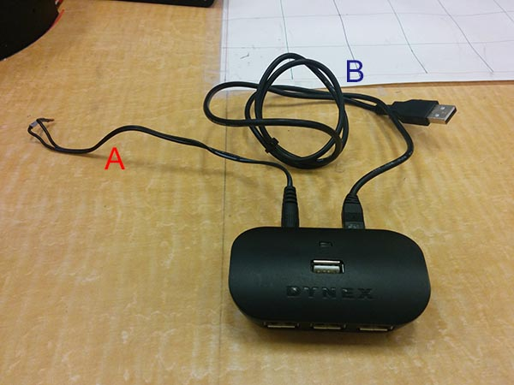

Fig 7. usb hub for thumper

In fig 7, wire A is the power source (5V) which is given by T’rex motor controller. Cable B is used to link to Raspberry Pi. There are totally 4 ports for this usb hub. All of them will be used. Because there is no other way to fix the usb hub on the flat frame surface, the easy way to solve the problem is glue the hub to the surface.

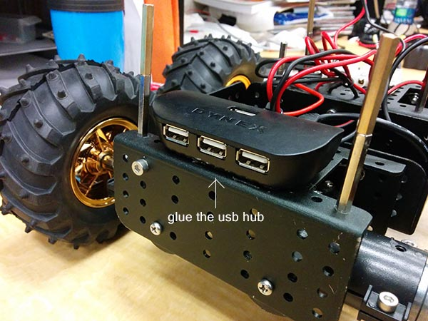

Fig 8. Placing the usb hub at the front of frame

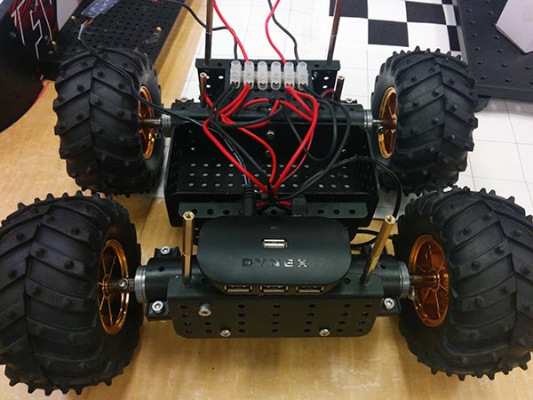

Fig 9. front view after place the usb hub

The usb wire which is the B cable in fig t is too long, so we placed it under the car frame like in fig 10 by using zip ties.

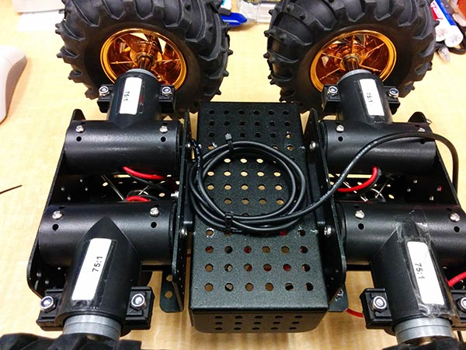

Fig 10. Wiring the usb at the bottom of the car frame

The first component which will be plugged to the usb hub is the wireless adapter which shows in fig 11.

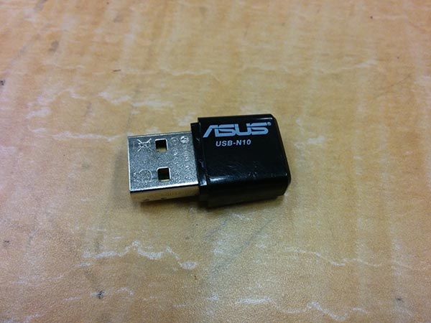

Fig 11. wireless adapter

The second and the third component are usb cables.

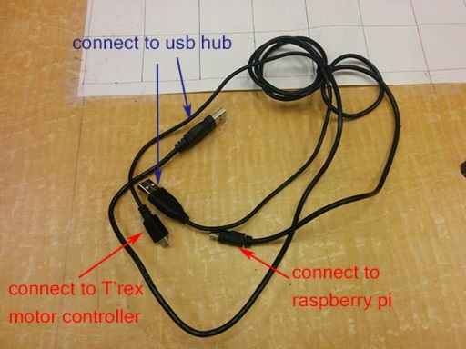

Fig 12. two usb cables for usb hub

In fig 12 it shows two cables. One will link between usb hub and T’rex motor controller. One is for connecting usb hub and raspberry pi.

The last component is a web camera which will be placed on the top platform. This one will be assembled later in step 5. Fig x is the overview of usb hub connection.

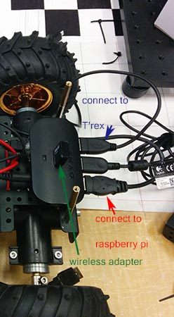

Fig 13. Connection of usb hub

Step 4:

Battery assembles.

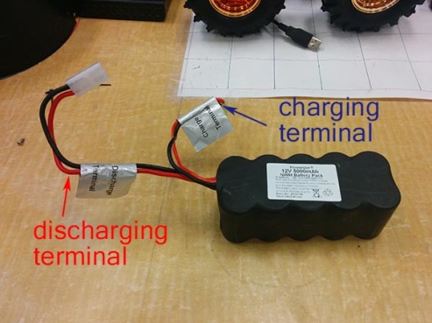

Fig 14. battery for thumper

In fig 14 it shows the battery used for thumper. There are two terminals. The charging terminal will link to the charging magnets which are used for charging the battery. The discharging terminal will link to the switch which is shown in fig 16.

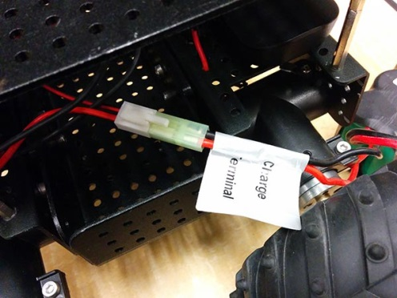

Fig 15. Connect the battery to charge terminal dock

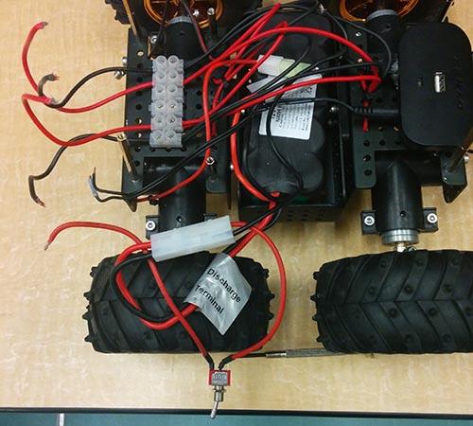

Fig 16. Connect the discharge terminal dock to switch

Finally place the battery on the center dock of the robot like in fig 17.

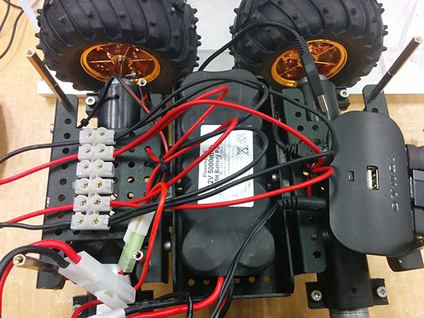

Fig 17. place the battery in the robot

Step 1 to step 4 are all focus on lower level of the car frame. From step 5 the top level will be added and all new components will be placed on the top level.

Step 5:

Add components to the top platform of thumper.

First of all, the T’rex motor controller should be added to the top platform.

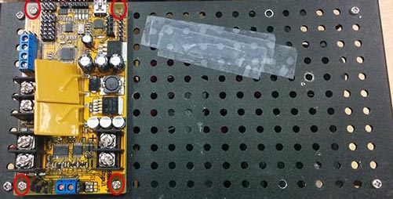

Fig 18. add T’rex to the top platform

In fig x it shows that there are some scratches on the top platform and they are taped. Those are caused by the pins under pi. So a protect case has been added and it should been fixed on the top platform. In fig x. there is a way to fix the case on the platform by using two zip ties.

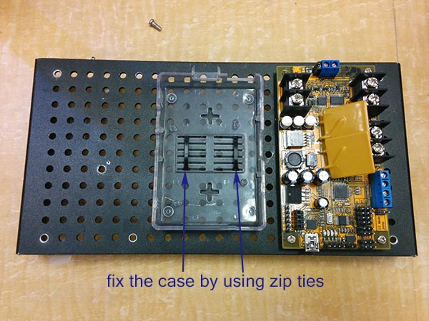

Fig 19. top platform with raspberry pi case and T’rex

The last is adding webcam to the platform.

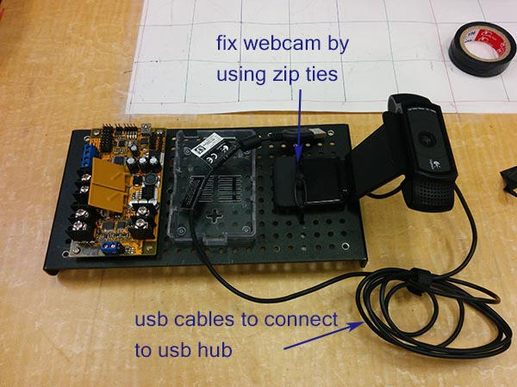

Fig 20. top platform with raspberry pi case, T’rex and webcam

Step 6:

Wire connections of T’rex motor controller.

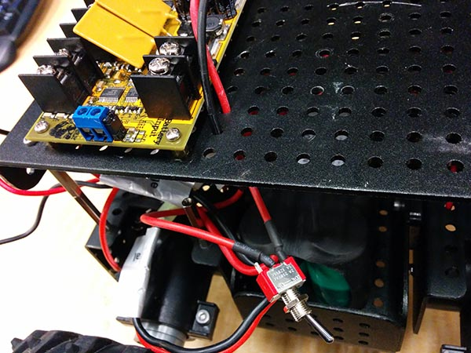

Fig 21. power supply wires from switch

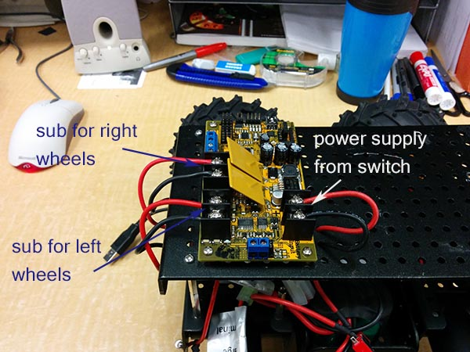

Fig 22. Connection of T’rex

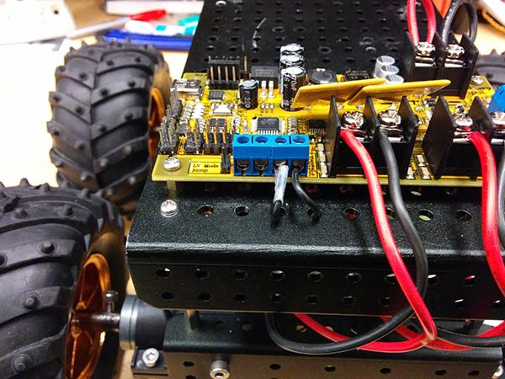

Fig 23. front view of T’rex wire connections

Note: For the cleanness of the wire connection, the case and webcam has been removed. In reality the case and webcam should be installed first.

The power supply port is 2 ports come from switch. The left/right wheels bus is directly from lower platform and the 5V output is for the power supply of usb hub.

Step 7:

Connect raspberry pi and the wireless adapter in to the system.



Fig 24. Connect raspberry pi into the system

All connection should connect as shown in fig 24.

Those are steps to assemble the thumper robot car.

1. **Appendix**
2. Table of components

